Zero Trust Network Access (ZTNA) with Zscaler: Securing User-to-Application Connectivity.

TEAM DETAILS

S.No. | Name | Register No. | Email
1 | Bubalan S | 2322K0227 | 23bcs013@kprcas.ac.in
2 | Gokul R | 2322K0230 | 23bcs023@kprcas.ac.in
3 | Haridev M | 2322K0238 | 23bcs024@kprcas.ac.in
4 | Visruti A | 2322K0283 | 23bcs069@kprcas.ac.in
College: KPR College of Arts Science and Research
College Code: bruaz

Project details

Title:

Zero Trust Network Access (ZTNA) with Zscaler: Securing User-to-Application Connectivity

AI-Enhanced User Protection (AIUP)
AI-Enhanced User Protection (AIUP) is an advanced cybersecurity framework that integrates artificial intelligence (AI) and machine learning (ML) to continuously authenticate users and safeguard digital platforms from evolving cyber threats. Unlike conventional security mechanisms that depend on static authentication factors such as passwords or even two-factor authentication (2FA), AIUP introduces an adaptive security layer that evaluates user behavior in real time. By analyzing behavioral signals—such as login patterns, typing speed, device usage, access location, and interaction patterns—the system generates a dynamic and continuously updated trust score for each user session.
This behavioral-driven approach enables AIUP to detect anomalies that traditional authentication systems often fail to identify. For example, if a legitimate user account is accessed from an unusual location or exhibits abnormal interaction behavior, the system can automatically trigger additional verification steps or block access entirely. As a result, AIUP transforms authentication from a one-time verification process into a continuous identity validation mechanism.
AIUP plays a critical role in modern cybersecurity because traditional perimeter-based defenses are increasingly ineffective against sophisticated attack techniques such as credential theft, phishing campaigns, session hijacking, and social engineering attacks. Conventional security models rely primarily on “what you know” (passwords) and “what you have” (tokens or authentication apps). AIUP introduces a third and more resilient dimension: “who you are” based on behavioral identity.

Abstract:
Zero Trust Network Access (ZTNA) is a modern cybersecurity architecture designed to provide secure access to enterprise applications based on identity, device posture, and contextual verification, rather than relying on traditional network-based trust models. The rapid adoption of cloud computing, remote work environments, and distributed applications has exposed significant weaknesses in conventional perimeter-based security systems such as Virtual Private Networks (VPNs). These legacy solutions were originally designed for centralized corporate networks and assume that users inside the network perimeter can be trusted. However, modern cyber threats have demonstrated that this assumption is no longer valid.
Traditional VPN solutions grant authenticated users broad access to internal networks once a connection is established. This approach increases the organization’s attack surface and enables attackers to perform lateral movement if they successfully compromise a user account or steal credentials. In addition, VPN infrastructure often introduces performance bottlenecks, requires complex management, and exposes network gateways to the public internet, making them attractive targets for cyber attackers. As organizations increasingly rely on remote employees, third-party vendors, and cloud services, these limitations have made VPN-based access control insufficient for protecting sensitive digital resources.
Zero Trust Network Access addresses these challenges by implementing the principle of “never trust, always verify.” Instead of granting users full network access, ZTNA establishes secure, application-level connections between authenticated users and the specific resources they are authorized to access. Each access request is evaluated based on multiple contextual factors including user identity, device security posture, location, and behavioral patterns. Only after successful verification is a secure micro-tunnel created between the user and the application.
By restricting access to individual applications rather than entire networks, ZTNA significantly reduces the attack surface and prevents unauthorized lateral movement. It also ensures that internal applications remain invisible to the public internet. As a result, ZTNA provides a scalable, cloud-native security solution that supports modern digital infrastructures while strengthening protection against advanced cyber threats.

Use Cases Scenarios:
Scenario 1: Secure Remote Access for Employees to Internal Business Applications

A remote employee needs to access the company’s internal project management application from home. Using ZTNA, the user connects securely without gaining access to the entire corporate network. The system verifies the employee’s identity through the organization’s identity provider and evaluates the device’s security posture before granting application access.

Output:

• User identity verified (Employee_Group)
• Device posture validated (endpoint protection active, system patched)
• Secure micro-tunnel established to Project Management Application only
• Internal network resources remain hidden from the user

Scenario 2: Secure Access for Third-Party Vendors

A third-party contractor requires temporary access to a software development portal hosted inside the organization’s infrastructure. Instead of connecting through a VPN, ZTNA provides controlled access only to the required application.

Output:

• Vendor identity authenticated through identity provider
• Access limited to Development Portal only
• No visibility into other internal network resources
• Secure encrypted connection established through ZTNA gateway

Scenario 3: Secure Access to Multicloud Applications

An enterprise hosts applications across multiple cloud platforms such as AWS and Azure. Employees need to access these applications securely without exposing them to the public internet. ZTNA provides direct user-to-application connectivity.

Output:

• User identity verified through enterprise SSO
• Context-based access policies enforced
• Secure application-level connection established to cloud application
• Backend cloud infrastructure remains hidden

Scenario 4: Secure Access for Bring-Your-Own-Device (BYOD) Users

An employee attempts to access a sensitive financial system using their personal laptop. ZTNA checks device posture to ensure that the device meets security policies before granting access.

Output:

• User identity verified through MFA
• Device posture evaluated (OS version, security patches, endpoint protection)
• Access granted only if device complies with policy
• Secure micro-tunnel established to Finance Application

Scenario 5: Secure Access During Mergers and Acquisitions

Two companies undergoing a merger need to allow employees to access selected applications across organizations without merging their entire networks. ZTNA enables controlled access between organizations.

Output:

• Cross-organization identity authentication completed
• Access restricted to approved applications only
• No direct network connectivity between companies
• Secure ZTNA tunnel established for application communication

STAGE - 1

Title of the Project:

Zero Trust Network Access (ZTNA) with Zscaler: Securing User-to-Application Connectivity.

Overview:

Modern digital systems face an increasing number of cybersecurity threats due to the rapid growth of cloud computing, remote work environments, and interconnected applications. Traditional security architectures relied on perimeter-based models that assumed users inside a corporate network were trustworthy once authenticated through mechanisms such as Virtual Private Networks (VPNs). However, this model has become ineffective as attackers frequently exploit stolen credentials, misconfigured systems, and vulnerable applications to gain unauthorized access. To address these challenges, modern security frameworks integrate principles from both Zero Trust Network Access (ZTNA) and secure application development standards promoted by organizations such as OWASP. OWASP is a global nonprofit community focused on improving software security by providing open resources, tools, and guidelines that help organizations build, deploy, and maintain secure applications. Its well-known OWASP Top 10 identifies the most critical web application vulnerabilities and serves as a global awareness standard for developers and security professionals. These vulnerabilities include issues such as broken access control, cryptographic failures, injection attacks, and security misconfiguration, which are among the most common causes of data breaches and system compromises.

In parallel, Zero Trust Network Access represents a modern cybersecurity architecture designed to eliminate the weaknesses of traditional network-based trust models. Instead of granting users full access to internal networks after authentication, ZTNA enforces the principle of “never trust, always verify” by validating every access request based on user identity, device security posture, and contextual information such as location and behavior. In a ZTNA environment, users are connected directly to specific applications rather than the entire corporate network, which significantly reduces the attack surface and prevents attackers from moving laterally across systems if an account becomes compromised. The integration of ZTNA with secure development practices aligned with OWASP recommendations creates a robust security ecosystem where both network access control and application-level protection work together to defend against cyber threats.

The working process in a Zero Trust–based architecture begins when a user attempts to access an application hosted either in a cloud platform or within a private enterprise environment. The system first verifies the identity of the user through authentication services such as Single Sign-On or Multi-Factor Authentication. After identity verification, the security framework evaluates the device posture by checking system updates, endpoint protection status, and compliance with

organizational policies. Once these checks are completed, an access policy engine analyzes contextual parameters including user role, risk score, and access location. If the request satisfies

all security requirements, a secure encrypted micro-tunnel is created between the user and the specific application without exposing the internal network. Throughout the session, the system continuously monitors user behavior to detect anomalies, automatically blocking access if suspicious activity occurs. This approach ensures that users only interact with the resources they are authorized to access while keeping the underlying network infrastructure invisible to unauthorized entities.

By combining the application security principles promoted by OWASP with the identity-centric access control model of ZTNA, organizations can significantly strengthen their cybersecurity posture. OWASP guidelines help developers design secure software and reduce vulnerabilities within applications, while ZTNA protects the infrastructure by controlling how users connect to those applications. This layered security strategy mitigates risks such as credential theft, phishing attacks, insider threats, and unauthorized data exposure. As enterprises increasingly adopt cloud services, remote work models, and distributed systems, integrating OWASP-based secure coding practices with Zero Trust Network Access provides a scalable and resilient approach to protecting sensitive resources and ensuring secure digital interactions across modern IT environments.

List of Vulnerability Table:
S. No. | Vulnerability Name | CWE Number
1 | Relative Path Traversal | CWE-23
2 | Active Debug Code | CWE-489
3 | Software Supply Chain Compromise | CWE-829
4 | Weak Cryptographic Implementation | CWE-327
5 | SQL Injection in Hibernate Queries | CWE-564
6 | Missing Encryption of Sensitive Data | CWE-311
7 | Use of Hard-coded Password | CWE-259
8 | Inclusion of Functionality from Untrusted Control Sphere | CWE-829
9 | Improper Output Neutralization for Logs (Log Injection) | CWE-117
10 | NULL Pointer Dereference | CWE-476

REPORT: -

Vulnerability Name: Relative Path Traversal

CWE- 23

OWASP Category: A01:2021 – Broken Access Control

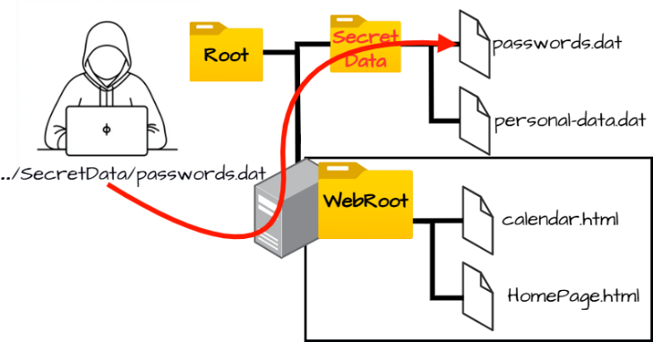
Description: Relative Path Traversal occurs when an application constructs file paths using user input without proper validation, allowing attackers to manipulate directory sequences like “../”, which enables them to move outside the intended directory and access sensitive files on the server.
Business Impact: Attackers can gain unauthorized access to confidential system files, configuration data, or credentials, which may lead to data breaches, system compromise, operational disruption, and significant financial and reputational damage to the organization.

Recommendation:
- Input Validation: Validate and sanitize all user inputs used in file paths and allow only predefined safe values.
- Path Canonicalization: Normalize and verify file paths to remove traversal sequences such as “../” before accessing files.
- Access Control Restrictions: Restrict file access to specific directories and enforce strict file permissions to prevent unauthorized file access.

Vulnerability Name: Active Debug Code

CWE-489

OWASP Category: A02:2021 – Security Misconfiguration

Description: Active Debug Code occurs when a software product is released with debugging or testing code still enabled in the production environment, which can expose internal application behavior and create unintended entry points for attackers, potentially allowing them to manipulate application functions or bypass security controls.
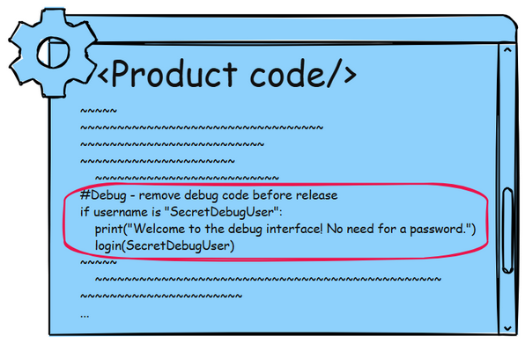
Business Impact: If debug functionality remains active in a deployed system, attackers may exploit it to access sensitive application data, bypass authentication mechanisms, or gain elevated privileges, which could ultimately lead to full compromise of the application or underlying server infrastructure.

Recommendation:

- Remove Debug Code Before Deployment: Ensure that all debugging functions, testing endpoints, and development backdoors are completely removed or disabled before deploying the application to production environments.
- Implement Secure Configuration Management: Adopt strict configuration management practices to ensure that debug modes, logging levels, and development settings are not enabled in production systems.
- Perform Security Testing and Code Review: Conduct static code analysis, penetration testing, and security reviews to detect leftover debug code and other insecure development artifacts before releasing the application.

Vulnerability Name: Software Supply Chain Compromise

CWE-829

OWASP Category: A03:2025 – Software Supply Chain Failures

Description: Software supply chain failures occur when an application relies on third-party libraries, dependencies, or components that contain vulnerabilities or malicious code, which can compromise the security of the entire system.
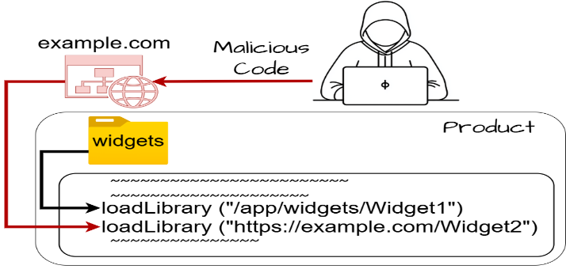
Business Impact: Attackers may inject malicious code through compromised dependencies, leading to system compromise, data theft, and large-scale attacks affecting multiple organizations.

Recommendation:

- Dependency Verification: Use trusted repositories and verify the integrity of third-party libraries before including them in the application.
- Regular Dependency Updates: Continuously update and patch third-party components toreduce exposure to known vulnerabilities.
- Supply Chain Monitoring: Use automated tools to scan and monitor software dependencies for security risks.

- Vulnerability Name: Weak Cryptographic Implementation

CWE - 327

OWASP Category: A04:2025 – Cryptographic Failures

Description: Cryptographic failures occur when sensitive data is protected using weak encryption algorithms, improper key management, or insecure transmission mechanisms.
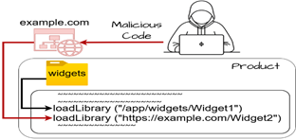
Business Impact: Weak encryption may allow attackers to decrypt confidential data such as passwords, financial information, or personal records.

Recommendation:
- Use Strong Encryption: Implement modern encryption standards such as AES-256 and TLS 1.3 to secure sensitive data.
- Secure Key Management: Store cryptographic keys securely and rotate them periodically to prevent misuse.
- Encrypt Sensitive Data: Ensure that all sensitive data is encrypted both in transit and at rest.

Vulnerability Name: SQL Injection in Hibernate Queries
CWE-564
OWASP Category: A05:2025 – Injection
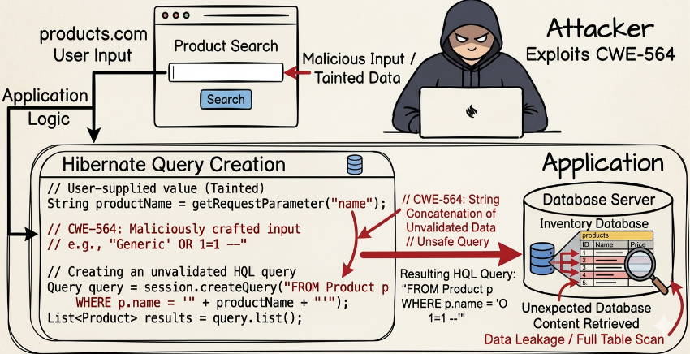
Description: SQL Injection in Hibernate occurs when an application builds Hibernate Query Language (HQL) statements using unvalidated user input, allowing attackers to manipulate the query structure and execute unauthorized database commands through the Hibernate framework.

Business Impact: Attackers may retrieve, modify, or delete sensitive database records, potentially leading to data breaches, unauthorized access to user information, and compromise of the entire application database.
Recommendation:
- Use Parameterized Queries: Always use parameter binding in Hibernate queries to prevent user input from being interpreted as executable query code.
- Input Validation: Validate and sanitize all user inputs before using them in HQL queries to ensure that malicious characters or commands are rejected.
- Least Privilege Database Access: Configure database accounts with minimal privileges so that even if an injection occurs, the attacker cannot perform critical operations.

Vulnerability Name: Missing Encryption of Sensitive Data

CWE – 311

OWASP Category: A04:2025 – Cryptographic Failures
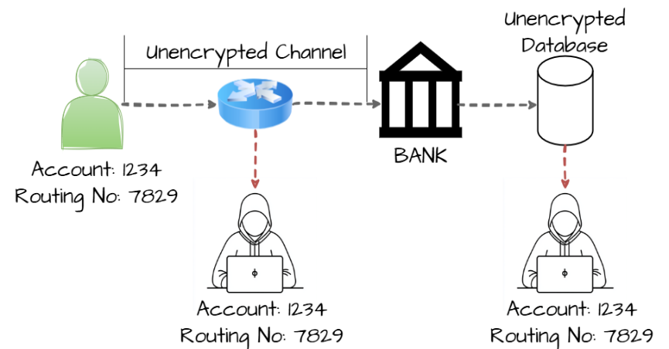
Description: This vulnerability occurs when sensitive information such as passwords, personal data, or financial details is stored or transmitted without proper encryption, making it accessible to unauthorized parties who may intercept or access the data.

Business Impact: Attackers may capture or read sensitive data through network interception or unauthorized system access, which can lead to data breaches, identity theft, financial loss, and reputational damage for the organization.

Recommendation:

- Encrypt Sensitive Data: Use strong encryption algorithms such as AES or TLS to protect sensitive data during storage and transmission.
- Secure Communication Channels: Ensure that all data exchanges occur over secure protocols like HTTPS instead of insecure protocols such as HTTP.
- Proper Key Management: Store and manage encryption keys securely and rotate them periodically to prevent unauthorized access.

Vulnerability Name: Use of Hard-coded Password

CWE- 259

OWASP Category: A07- 2025 – Authentication Failures

Description: This vulnerability occurs when a password is directly embedded in the application source code or configuration files, allowing anyone who gains access to the code to easily discover and use the credentials to access the system.
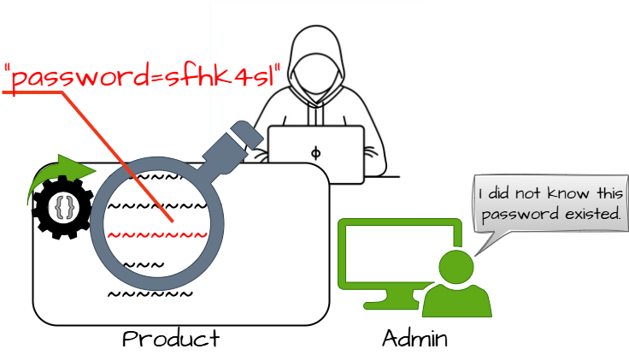
Business Impact: Attackers who obtain the hard-coded password may gain unauthorized access to applications, databases, or administrative functions, potentially leading to data breaches, system compromise, and loss of sensitive information.

Recommendation:

- Use Secure Credential Storage: Store passwords securely using environment variables or dedicated secret management systems instead of embedding them in source code.
- Implement Strong Authentication: Use secure authentication mechanisms such as token- based authentication or multi-factor authentication to reduce reliance on static passwords.
- Regular Credential Rotation: Frequently change passwords and remove hard-coded credentials from the application to minimize the risk of unauthorized access.

Vulnerability Name: Inclusion of Functionality from Untrusted Control Sphere

CWE- 829

OWASP Category: A03:2025 – Software Supply Chain Failures

Description: This vulnerability occurs when an application loads or executes code from external or untrusted sources without proper validation, which may allow attackers to introduce malicious components into the system.

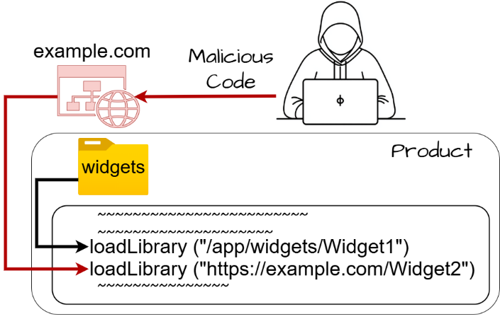
Business Impact: Attackers can inject malicious libraries or scripts into the application, leading to unauthorized code execution, system compromise, or large-scale supply chain attacks affecting multiple systems.

Recommendation:

- Validate External Sources: Ensure all external libraries and modules are obtained from trusted repositories and verified before use.
- Implement Integrity Checks: Use digital signatures or hash verification to confirm that external components have not been tampered with.
- Limit External Code Execution: Restrict the application from dynamically loading code from unknown or untrusted sources.

Vulnerability Name: Improper Output Neutralization for Logs (Log Injection)

CWE- 117

OWASP Category: A09:2025 – Security Logging and Alerting Failures
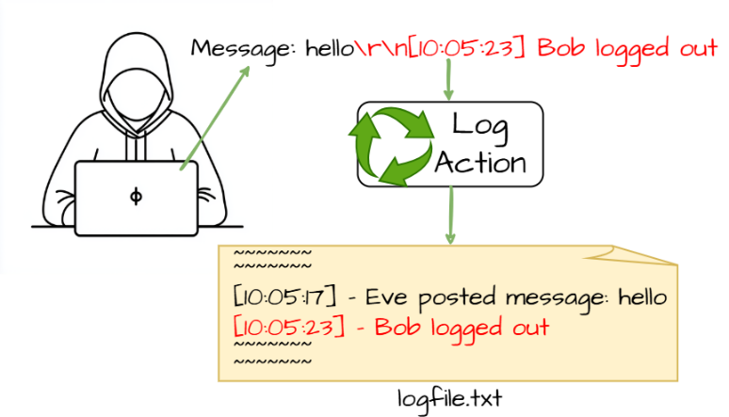
Description: This vulnerability occurs when user-controlled input is written directly to log files without proper sanitization, allowing attackers to manipulate log entries or inject malicious content.

Business Impact: Attackers can alter or forge log records, hide malicious activities, or inject misleading information, which may disrupt security monitoring and incident investigations.

Recommendation:

- Sanitize Log Inputs: Filter or encode user input before writing it to log files to prevent injection attacks.
- Use Structured Logging: Implement standardized logging formats that prevent manipulation of log entries.

- Protect Log Integrity: Restrict access to log files and implement monitoring to detect unauthorized changes.

10) Vulnerability Name: NULL Pointer Dereference

CWE- 476

OWASP Category: A10:2025 – Mishandling of Exceptional Conditions

Description: This vulnerability occurs when a program attempts to access or dereference a pointer that has a NULL value, which may cause the application to crash or behave unpredictably.
Business Impact: Exploiting this vulnerability may result in system crashes, denial of service, or instability of the application, affecting availability and reliability of the system.
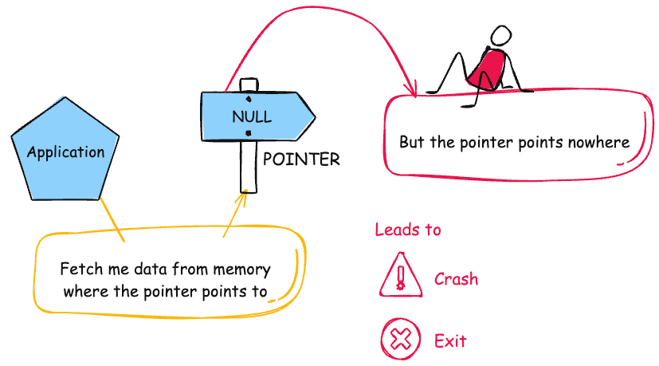
Recommendation:

1. Validate Pointers Before Use: Always check whether a pointer is NULL before accessing it in the program.
2. Implement Proper Exception Handling: Use error handling mechanisms to manage unexpected conditions safely.
3. Perform Secure Code Reviews: Conduct regular code reviews and testing to detect and fix potential NULL pointer issues.

STAGE – 2

TITLE: NESSUS SCAN

Overview : -

Nessus is a robust vulnerability assessment tool developed by Tenable, Inc. designed to identify security gaps across an organization's infrastructure. It operates as a remote scanner, which means it probes target hosts over the network without requiring any software installation on the targets themselves. By sending a diverse array of probes—including network traffic patterns, operating system commands, and specific application requests—Nessus can accurately map out an attack surface and pinpoint potential entry points for attackers.

The power of Nessus lies in its plugin-based architecture, which allows for frequent updates to keep pace with new threats. Plugins are modular scripts designed to detect specific vulnerabilities, and Nessus currently utilizes over 210,000 of them to cover a massive range of operating systems, network devices, and software applications. This system ensures that the scanner remains versatile, whether it is checking for a decade-old bug or a zero-day exploit released just hours ago.

When performing a web page scan, Nessus utilizes a dedicated Web Application Scanning (WAS) engine to navigate the complexities of modern sites. The process begins with a discovery phase where Nessus crawls the URL to map out the site's structure, including hidden directories and API endpoints. It then runs targeted plugins to test for web-specific flaws like SQL Injection or Cross-Site Scripting (XSS). Once the scan is complete, Nessus generates a prioritized report that details each vulnerability's severity, evidence of the flaw, and clear remediation steps to help developers secure the page.

Nessus can be used to scan a variety of targets, including single hosts, networks, and web applications. It can also be used to scan specific ports and services. Nessus can be configured to run scans on a schedule or manually.

Here is a step-by-step explanation of how Nessus works:

- Nessus connects to the target host using a variety of protocols, including TCP, UDP, and ICMP.
- Nessus sends a series of probes to the target host in order to identify its operating system and services.
- Nessus runs a series of plugins to test for vulnerabilities.
- Nessus generates a report that includes the severity of each vulnerability, the steps to reproduce the vulnerability, and the steps to remediate the vulnerability.

Nessus is a valuable tool for security professionals who need to identify and remediate vulnerabilities in their networks. It is easy to use and provides comprehensive reports that can be used to prioritise remediation efforts.

Here are some of the benefits of using Nessus:

  - Comprehensive vulnerability coverage: Nessus has over 1200 plugins available, covering a wide range of vulnerabilities in operating systems, applications, and network devices.
  - Easy to use: Nessus has a user-friendly interface that makes it easy to configure and run scans.
  - Comprehensive reporting: Nessus provides detailed reports that include the severity of each vulnerability,the steps to reproduce the vulnerability, and the steps to remediate the vulnerability.
  - Scalability: Nessus can be used to scan a variety of targets, including single hosts, networks, and web applications.
  - Flexibility: Nessus can be configured to run scans on a schedule or manually.

Nessus is a powerful tool that can be used to improve the security of any network. It is a valuable asset for any security professional.

Target website : - https://ginandjuice.shop/
Target ip address: - 34.249.203.140

List of Vulnerability: -

S. No | Vulnerability Name | Severity | Plugin
1 | HSTS Missing From HTTPS Server (RFC 6797) | Medium | 142960
2 | SSL Certificate Information Disclosure | Info | 10863
3 | SSL/TLS Recommended Cipher Suites | Info | 56984
4 | TLS NPN Supported Protocol Enumeration | Info | 87242
5 | Web Server Crafted Request Vendor/Version Information Disclosure | Info | 11239
6 | Service Detection | Info | 22964
7 | Nessus SYN Scanner | Info | 11219
8 | Nessus Scan Information | Info | 19506
9 | TLS Version 1.2 Protocol Detection | Info | 136318
10 | HyperText Transfer Protocol (HTTP) Information | Info | 24260

REPORT: -

- Vulnerability Name: - 142960 - HSTS Missing From HTTPS Server (RFC 6797)
Severity: - MEDIUM
Plugin: - 142960

Port: - 443/TCP
Description: - The remote web server is not enforcing HSTS, as defined by RFC 6797. HSTS is an optional response header that can be configured on the server to instruct the browser to only communicate via HTTPS. The lack of HSTS allows downgrade attacks, SSL-stripping man-in-the-middle attacks, and weakens cookie-hijacking protections.
Solution: - Configure the remote web server to use HSTS.
Business Impact: - The absence of HSTS makes the website vulnerable to downgrade and man-in-the-middle attacks, allowing attackers to intercept or manipulate user communications. Sensitive information such as login credentials and session cookies may be exposed during insecure HTTP connections. This can lead to unauthorized account access and data breaches. As a result, the organization may face loss of user trust, reputational damage, and potential compliance issues.

- Vulnerability Name: -10863-SSL Certificate Information Disclosure
Severity: - INFO
Plugin: - 10863

Port: - 443/TCP
Description: - The plugin connects to the SSL service and retrieves the X.509 certificate information used by the server. It displays details such as issuer, validity period, encryption algorithm, and key length. This is mainly used for informational and verification purposes.
Solution: - Ensure that the SSL certificate is valid, uses strong encryption, and is renewed before expiration. Regular certificate monitoring is recommended.
Business Impact: - This finding is informational but may reveal certificate and server configuration details. Attackers could use this information during reconnaissance. Proper certificate management helps maintain secure communication.

Vulnerability Name: - 56984 - SSL/TLS Recommended Cipher Suites-

Severity: - INFO
Plugin: - 56984

Port: - 443
Description: - The remote host has open SSL/TLS ports which advertise discouraged cipher suites. It is recommended to only enable support for the following cipher suites
Solution: - Only enable support for recommened cipher suites.

Business Impact: - If weak cipher suites are enabled, attackers may exploit them to weaken encrypted communications. This can lead to potential data interception or cryptographic attacks. Using strong cipher suites ensures secure data transmission and improves system security.

Vulnerability Name: - 87242 - TLS NPN Supported Protocol Enumeration

Severity: - INFO
Plugin: - 87242

Port: - 443/TCP
Description: - The plugin checks whether the server supports TLS Next Protocol Negotiation (NPN). It enumerates the protocols that the server can negotiate during the TLS handshake. This information helps identify the protocols supported by the server for secure communication.
Solution: - Review the supported protocols and ensure only secure and required protocols are enabled. Disable outdated or unnecessary protocols to reduce the attack surface. Regularly update TLS configurations to follow security best practices.
Business Impact: - Although informational, exposed protocol details may assist attackers during reconnaissance. Knowledge of supported protocols can help attackers identify potential weaknesses. Proper configuration reduces the risk of protocol-based attacks.

5) Vulnerability Name: - 11239 - Web Server Crafted Request Vendor/Version Information Disclosure

Severity: - INFO
Plugin: - 11239

Port: - 443/TCP
Description: - The web server running on the remote host appears to be hiding its version or name, which is a good thing. However, using a specially crafted request, Nessus was able to discover the information.
Solution: - No generic solution is known. Contact your vendor for a fix or a workaround.
Business Impact: - Disclosure of server vendor and version information may assist attackers in identifying known vulnerabilities. Attackers can use this information to plan targeted attacks against the system. Hiding server details helps reduce the risk of reconnaissance-based attacks.

6) Vulnerability Name: - 22964 - Service Detection

Severity: - INFO
Plugin: - 22964

Port: - 80
Description: - Nessus was able to identify the remote service by its banner or by looking at the error message it sends when it receives an HTTP request.
Solution: - N/A
Business Impact: - Service information disclosure may help attackers understand the system environment. This information can be used during reconnaissance to identify potential attack points. Limiting exposed services reduces the overall attack surface.

7) Vulnerability Name: - 11219 - Nessus SYN scanner

Severity: - INFO
Plugin: - 11219

Port: - 80 (or) 443
Description: - This plugin is a SYN 'half-open' port scanner. It shall be reasonably quick even against a firewalled target. Note that SYN scans are less intrusive than TCP (full connect) scans against broken services, but they might cause problems for less robust firewalls and also leave unclosed connections on the remote target, if the network is loaded.
Solution: - Protect your target with an IP filter.
Business Impact: - Open ports can expose network services to potential attackers. Attackers may use this information to identify entry points for further attacks. Proper port management helps reduce the risk of unauthorized access.

8) Vulnerability Name: - 19506 – Nessus Scan Information

Severity: - INFO
Plugin: - 19506

Port: - N/A
Description: - This plugin provides information about the Nessus scan performed on the target host. It includes details such as the scanner type, Nessus engine version, plugin set version, and the port scanning method used. It also shows scan date, duration, port range scanned, and parallel host/check configuration.
Solution: - No remediation is required since this is an informational plugin. Ensure that scan reports are stored securely and accessible only to authorized personnel.
Business Impact: - This finding does not indicate a vulnerability but provides details about the scanning process. However, exposed scan information could reveal security assessment activities if accessed by unauthorized users. Proper access control for scan reports is recommended.

9) Vulnerability Name: - 136318 - TLS Version 1.2 Protocol Detection

Severity: - INFO
Plugin: - 136318

Port: - 443
Description: - This plugin detects whether the remote service supports TLS version 1.2 for secure communication. TLS 1.2 is a widely used protocol that provides strong encryption and secure data transmission between clients and servers. The result confirms the availability of this protocol on the target system.
Solution: - Ensure that TLS 1.2 or higher versions such as TLS 1.3 are enabled for secure communication. Disable older and insecure protocols like SSL and TLS 1.0/1.1 to improve security.
Business Impact: - Supporting TLS 1.2 improves the security of encrypted communications. However, if older protocols are also enabled, attackers may attempt downgrade attacks. Proper TLS configuration ensures strong data protection.

10) Vulnerability Name: - 24260 - HyperText Transfer Protocol (HTTP) Information

Severity: - INFO
Plugin: - 24260

Port: - 80 (or) 443

Description: - This test gives some information about the remote HTTP protocol - the version used, whether HTTP Keep-Alive is enabled, etc…This test is informational only and does not denote any security problem.
Solution: - Configure the web server to limit unnecessary HTTP methods and hide server information in HTTP headers. Implement proper security configurations to reduce information disclosure.
Business Impact: - Disclosure of HTTP service information may assist attackers in identifying server configurations. Attackers can use this data during reconnaissance to plan further attacks. Restricting unnecessary information improves overall security.

STAGE – 3
Title: - Implementing Zero Trust Network Access (ZTNA) with Zscaler: Securing User-to-Application Connectivity
Overview:

- Zero Trust Network Access (ZTNA)
Zero Trust Network Access (ZTNA) is an IT security framework that provides secure remote access to an organization's internal applications and data based on clearly defined access control policies. Unlike traditional Virtual Private Networks (VPNs), which grant users broad access to the entire network, ZTNA operates on a "never trust, always verify" principle. It grants users access only to the specific applications they need, and only after their identity and device have been verified.
ZTNA is a critical component of modern security architecture. It helps organizations move away from the concept of a trusted internal network and an untrusted external network (the "castle- and-moat" model). By hiding the internal network from the internet and establishing one-to-one, encrypted connections between users and applications, ZTNA drastically reduces the attack surface and stops common threats like lateral movement by attackers.
- The ZTNA Access Cycle
The ZTNA cycle is a continuous process of verifying identity, establishing secure connections, and enforcing policy for every access request. It typically consists of the following steps:
- User Request: A user, from any location (office, home, coffee shop), requests access to a specific internal application (e.g., an HR portal, a finance server, or an internal code repository).
- Identity and Device Verification: Before any connection is established, the ZTNA solution verifies who the user is (via multi-factor authentication, or MFA) and checks the security posture of their device. This includes ensuring the device has up-to-date antivirus, a healthy firewall, and is not compromised.
- Policy Enforcement: The ZTNA solution checks the access policy. Does this specific user, with this specific device, have permission to access the requested application at this specific time?
- Establish Secure Connection: If the policy allows access, the ZTNA solution creates a highly secure, encrypted micro-tunnel between the user's device and the target application. Crucially, the user never gains access to the underlying network, only to the application itself.
- Continuous Monitoring: The ZTNA solution continues to monitor the connection for anomalies. If the user's behavior becomes suspicious or their device posture changes, the connection can be terminated in real-time.
- Logging and Analytics: All access attempts, successful and failed, are logged and analyzed. This data is used for auditing, threat hunting, and refining access policies.

  - Zscaler (Zscaler Internet Access / Zscaler Private Access)
Zscaler is a cloud-native security platform that delivers its services entirely from the cloud, eliminating the need for on-premises hardware like VPN concentrators. For ZTNA, Zscaler offers Zscaler Private Access (ZPA) . ZPA is a service that provides seamless, identity-based access to private applications without ever placing users on the network.
Zscaler ZPA operates on a simple principle: the application is "inside" the Zscaler cloud, and the user connects to it there. It collects data from a variety of sources, including:
- Identity Providers (IdP): Such as Azure AD, Okra, or Ping Identity, to verify user identities.
- Device Posture Partners: Such as CrowdStrike, Tanium, or Microsoft Defender for Endpoint, to check the health of the endpoint.
- Business Applications: The internal web apps, file servers, and legacy applications hosted in data centers or public clouds (e.g., AWS, Azure).
- Zscaler App Connectors: Lightweight software components deployed in the data center or cloud that initiate outbound connections to the Zscaler cloud, making internal servers invisible to the internet.

Zscaler then enforces policies based on this data, including:
- Identity-Based Access: Policies are built around user and group identities, not IP addresses.
- Application Segmentation: Users are granted access to specific applications, not entire subnets.

- Least Privilege Access: Ensures users have the minimum level of access required to perform their jobs.

The Zscaler ZTNA Cycle
The Zscaler ZTNA cycle is the practical application of the ZTNA principles using the Zscaler cloud. The cycle typically consists of the following steps:
- User Login and Authentication: A user attempts to access an internal application. They are redirected to their organization's Identity Provider (IdP) for authentication and MFA.
- Device Posture Check (Integration): Zscaler checks with integrated endpoint protection tools to ensure the device is compliant with security policies.
- Policy Lookup and Decision: The Zscaler cloud evaluates the request against the defined access policies. It verifies that the user, device, and context (time, location) are authorized for that specific application.
- Establishing the Micro-tunnel: Once authorized, the Zscaler cloud instructs the user's Zscaler Client Connector and the appropriate Zscaler App Connector in the data center to establish an encrypted connection. The user is now connected to the application.
- Traffic Inspection (Optional): For sanctioned applications, Zscaler can optionally inspect the traffic for data loss prevention (DLP) or to detect malware.
- Logging and Analytics: All activity is logged in the Zscaler cloud portal for reporting, threat hunting, and compliance.

MISP (Malware Information Sharing Platform) Integration
While Zscaler is a primary access control tool, it can be enhanced by integrating with threat intelligence platforms like MISP.
- Threat Intelligence Feed: MISP can aggregate and share threat intelligence about malicious domains, IPs, and URLs. This list of indicators of compromise (IOCs) can be fed into Zscaler's cloud.
- Proactive Blocking: If a user, even one authorized by ZPA, attempts to access a known malicious site that has been flagged by the MISP feed, Zscaler Internet Access (ZIA) can block the request, preventing a potential infection.
- Enhanced Visibility: Security teams can use MISP to cross-reference Zscaler logs. If a user's behavior is anomalous, the team can check MISP to see if the destination IP or domain is associated with a known threat actor or campaign.
  - My College Network Information
This infrastructure presents a large attack surface, especially with the need for remote learning and
administrative access. The network includes:
- Core routers and switches
- Distribution routers and switches
- Wireless access points
- Firewalls and Intrusion Detection Systems (IDS)
- Internal Application Servers: Hosting the student information system, library resources, research data repositories, and administrative portals.
- Legacy VPN Concentrator: Currently providing broad network-level access for faculty and staff working remotely.

The need for ZTNA arises from the limitations of the current VPN model:
- Over-permissioned Access: Once on the VPN, a faculty member's compromised laptop could potentially scan and attack the entire internal network (lateral movement).
- Hidden Applications: Some research applications need to be accessed by external collaborators without granting them full network access.
- User Experience: The legacy VPN can be slow and cumbersome, often requiring users to route all their internet traffic through the university.

  - How you think you deploy ZTNA using Zscaler in my college
To deploy Zscaler ZTNA (ZPA) in your college, you would start by identifying the specific applications that need to be secured and the user groups that need access to them. This is a shift from securing the network to securing access to applications.

The plan would need to include the following:
- Application Discovery: Catalog all internal applications (e.g., ERP, library system, research servers, file shares) and identify which ones are currently exposed via the VPN.
- User Segmentation: Define user groups (e.g., Students, Faculty - Research, Faculty - Admin, IT Staff, External Collaborators) and the specific applications each group needs.
- Deploying Zscaler App Connectors: Install lightweight App Connector VMs in the university's data center. These connectors will establish outbound connections to the Zscaler cloud, making the application servers invisible to the public internet.
- Integrating Identity Provider: Connect Zscaler to the university's existing Identity Provider (e.g., Microsoft Azure AD) to leverage current usernames, passwords, and MFA policies.
- Configuring Access Policies: Create granular policies in the Zscaler admin portal. For example: "The 'Faculty' group can access the 'ERP Application' from any device that has antivirus enabled, after MFA."
- Deploying Zscaler Client Connector: Students, faculty, and staff will install the Zscaler Client Connector on their laptops and mobile devices. This small client intelligently routes traffic for private applications through ZPA and public traffic through ZIA.

Threat Intelligence

In the context of Zscaler and ZTNA, threat intelligence is used to understand who is trying to access what, and from where. It helps move beyond simple identity checks to a more contextual understanding of risk.
Sources include:
- Zscaler Cloud Logs: Internal logs provide real-time data on who is accessing which applications, from which locations, and on what devices.
- External Threat Feeds (MISP): Information about new malware campaigns, phishing kits, or command-and-control servers being used by attackers.
- Identity Provider Logs: Anomalies in login attempts, such as a user logging in from two geographically impossible locations in a short time, can signal a compromised account.
This intelligence is used for:
- Adaptive Access Control: If threat intelligence suggests a user's location is high-risk, Zscaler can step-up authentication requirements or block access entirely.
- Hunting for Compromised Accounts: Analysts can use Zscaler logs to see if a user is suddenly accessing applications they never have before, which could be a sign of credential theft.

- Blocking Malicious Communication: Threat intelligence feeds can be used by Zscaler Internet Access (ZIA) to block outbound connections to known malicious sites, even if they originate from a user inside the university.

Incident Response (Adapted for ZTNA)
Incident response in a ZTNA model is faster and more targeted because the environment is inherently more controlled.
- Detection: The SOC team detects an anomaly. For example, a faculty account is downloading an unusually high volume of data from a research server at 3 AM. Zscaler logs provide the exact details: the user, the device, the application, and the amount of data transferred.
- Containment: The SOC team can instantly isolate the user. In the Zscaler portal, they can simply deactivate that user's access or block their specific device. Because there is no network- level access, this action immediately severs all connections to every application, preventing lateral movement.
- Eradication: The compromised device is taken offline for malware scanning and cleaning by the IT helpdesk.
- Recovery: Once the device is clean and the user's password is reset, the Zscaler policy is re- enabled, granting the user access again.
- Post-incident review: The security team analyzes the logs to understand how the account was compromised (e.g., a phishing email) and updates Zscaler policies, perhaps by adding a block for similar malicious domains or tightening access rules for that specific research application.
Benefits of this incident response approach:
- Near-Instant Containment: Actions take seconds in a cloud dashboard, not minutes or hours configuring firewall rules.
- No Lateral Movement: The attacker is contained to the single compromised application, protecting the rest of the university's network.
- Granular Forensics: Zscaler provides a detailed audit trail of every connection, making investigations faster and more accurate.
- Compliance: This model helps demonstrate compliance with data protection regulations by proving that access to sensitive student or research data is tightly controlled and audited.

Understanding about the tool (Zscaler ZPA)
Zscaler Private Access (ZPA) is a cloud service that embodies the ZTNA principle of "connect a user to an app, not the network." Here are the key things to understand:
- It is "Application-Centric," Not "Network-Centric": You define policies based on applications (e.g., "SAP Server 01"), not network constructs like IP subnets. This aligns security with how businesses actually operate.
- It Hides the Network: ZPA uses App Connectors inside your data center that only
make outbound connections to the Zscaler cloud. Your internal servers never need to open inbound firewall ports, making them invisible to port scanners and attackers on the internet.
- It uses a "Dark Cloud" Approach: To an external scanner, the organization's applications simply don't exist. They only become visible to authorized users after a multi-step verification process.
- It Provides a Superior User Experience: Users don't have to mess with clunky VPN clients. The Zscaler Client Connector works silently in the background. For web apps, access can even be agentless, requiring only a modern browser.
- It is Inherently Scalable: Because it's a cloud service, ZPA scales instantly to handle thousands of concurrent users, unlike a legacy VPN appliance that needs to be manually upgraded.

Conclusion: -
- Stage 1 Conclusion
Stage 1 focused on identifying common web application vulnerabilities using OWASP and CWE standards. Vulnerabilities such as path traversal, SQL injection, cryptographic failures, and hard-coded passwords were analysed to understand their causes and risks. This stage highlighted how insecure coding practices can expose applications to cyber attacks. By implementing proper validation, encryption, and secure coding methods, these risks can be reduced. Overall, this stage emphasized the importance of security during the development process.

- Stage 2 Conclusion
Stage 2 involved performing vulnerability assessment using the Nessus scanning tool. The scan identified several issues such as outdated TLS versions, weak encryption
parameters, and missing security headers. Even informational findings helped reveal system configuration details that could be useful for attackers. The Nessus report provided severity levels and remediation suggestions for each vulnerability. This stage demonstrated how automated scanning tools help organizations detect and fix security weaknesses effectively.

- Stage 3 Conclusion
Stage 3 focused on implementing Zero Trust Network Access (ZTNA) using the Zscaler platform. Unlike traditional VPNs, ZTNA verifies user identity and device status before granting access to applications. Users are connected only to the specific applications they need rather than the entire network. Zscaler Private Access establishes secure encrypted connections and continuously monitors access activities. This stage showed how Zero Trust architecture improves modern network security.Stage 1 illuminated the evolving landscape of web application testing. With advancements in AI, there is a promising avenue for more sophisticated testing methodologies, ensuring even higher levels of security for web applications.

Future Scope: -

Stage 1 – Web Application Vulnerability Analysis
Stage 1 focused on studying common web application vulnerabilities based on OWASP and CWE standards. Vulnerabilities such as path traversal, SQL injection, missing encryption, and hard-coded passwords were analysed to understand their impact on system security. These vulnerabilities occur due to poor input validation, weak security configurations, or insecure coding practices. Attackers can exploit these weaknesses to gain unauthorized access or compromise sensitive data. Understanding these vulnerabilities helps developers implement better security controls and improve application security.

Stage 2 – Vulnerability Assessment Using Nessus
Stage 2 involved performing vulnerability scanning using the Nessus tool to identify security issues in a web application. Nessus scans the target system and detects vulnerabilities related to network services, encryption protocols, and system configurations. The scan results showed issues such as deprecated TLS versions, weak cryptographic parameters, and missing security headers. Each vulnerability was categorized based on severity and included recommendations for remediation. This stage demonstrated the importance of vulnerability assessment in strengthening system security.

Stage 3 – Implementing ZTNA Using Zscaler
Stage 3 focused on implementing Zero Trust Network Access using the Zscaler security platform. ZTNA follows the principle of “never trust, always verify,” ensuring that every access request is authenticated and validated. Zscaler Private Access allows users to securely connect only to authorized applications instead of the entire network. It verifies user identity, device security posture, and contextual factors before granting access. This approach reduces the attack surface and prevents unauthorized access, improving overall cybersecurity.
Topics Explored:
- Data Collection and Aggregation
- Owasp Top 10
- Scanning
- Vulnarability
- Awarness and Identity
- Standardization and Normalisation
- Enrichment and Analysis
- Integration with Security Tools
- Customization and Flexibility
Tools Explored:
- Zscaler
- Website
- Nessus
- OWASP ZAP
- ginandjuice

